
Quotation
taqnyat.sa

Version.4.0
The Date :
Offer Number:
Customer Name :
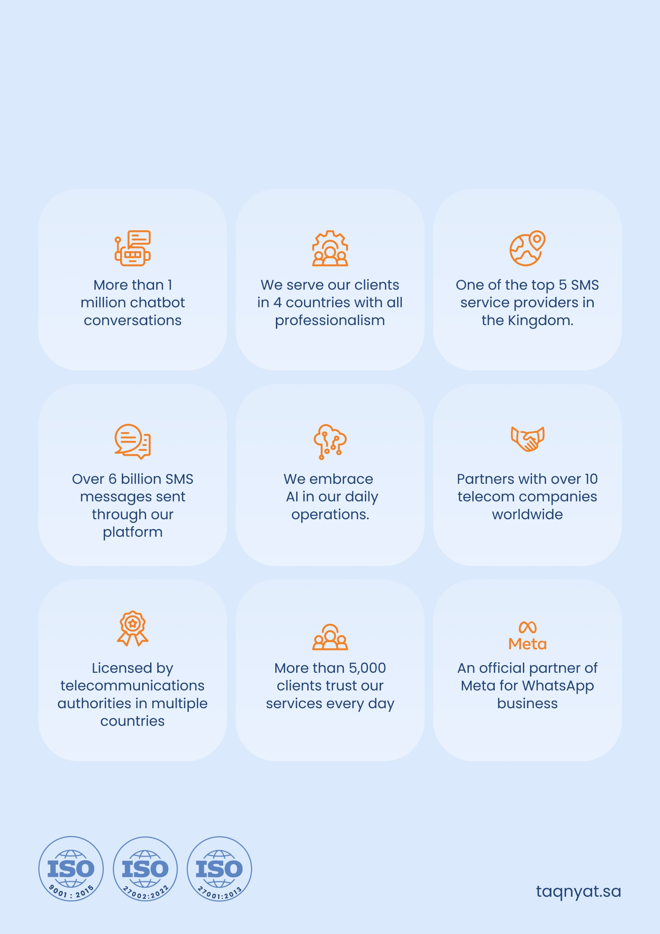
Taqnyat in Brief

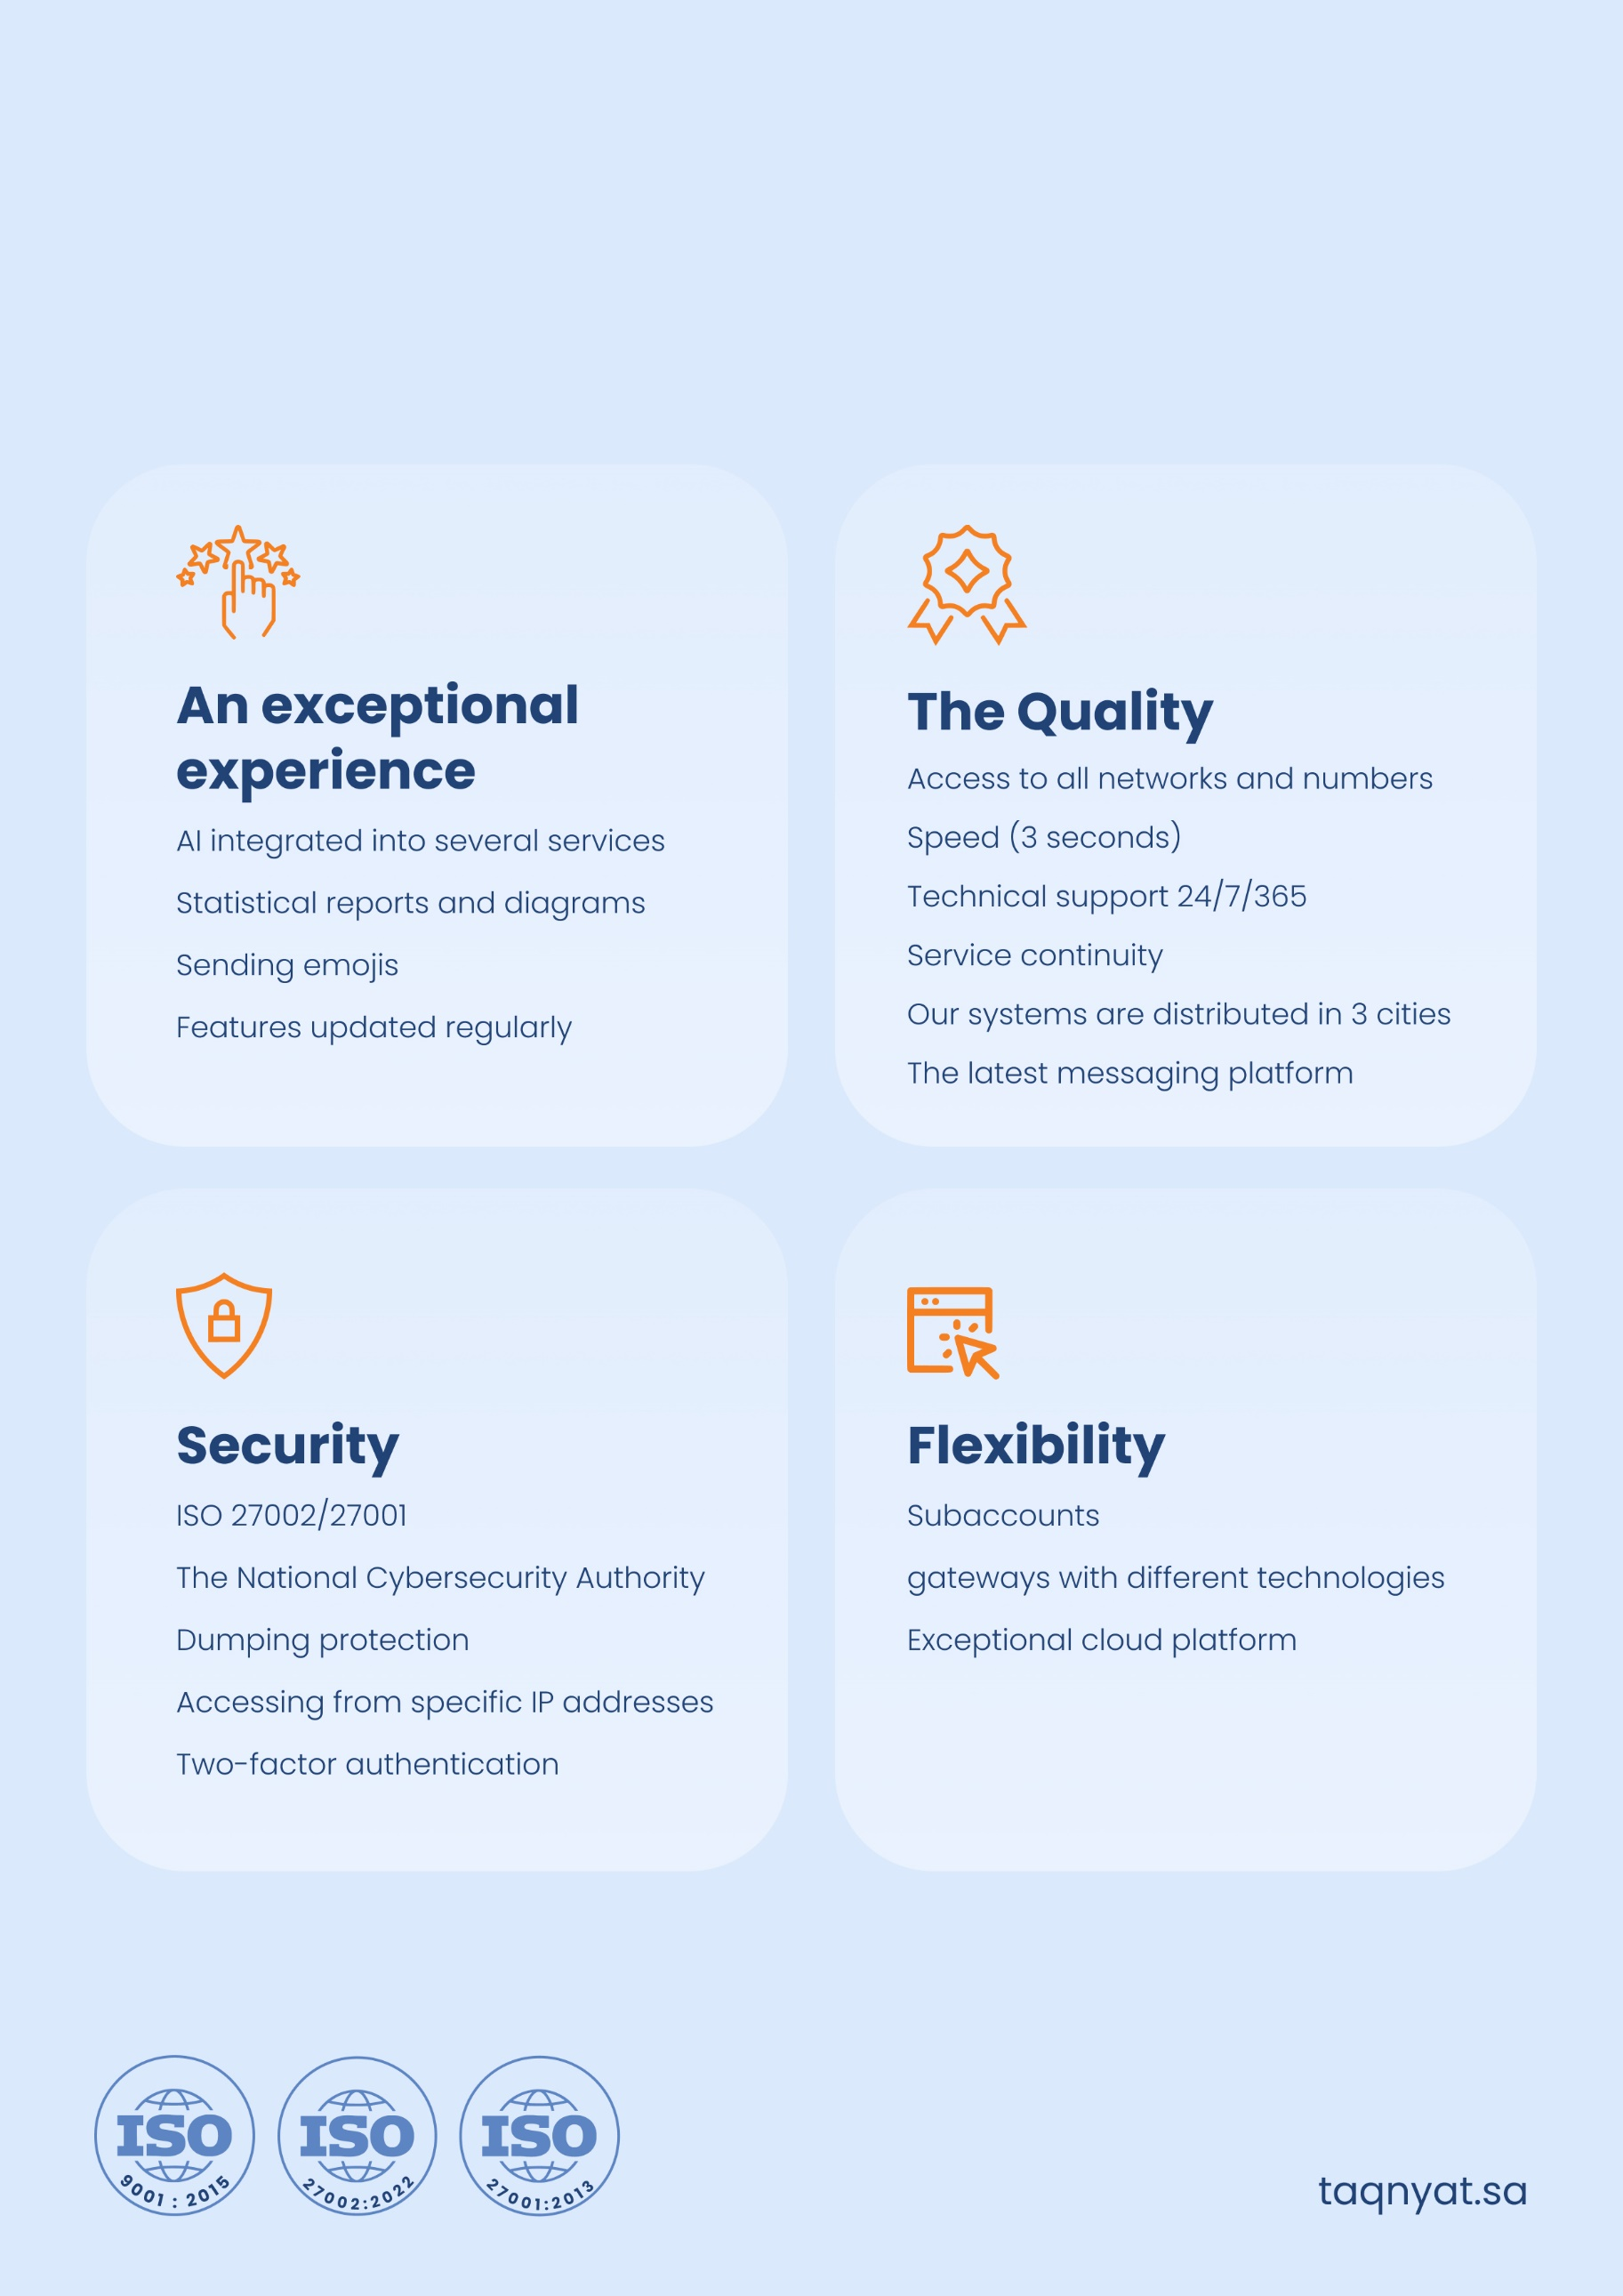
We are Committed

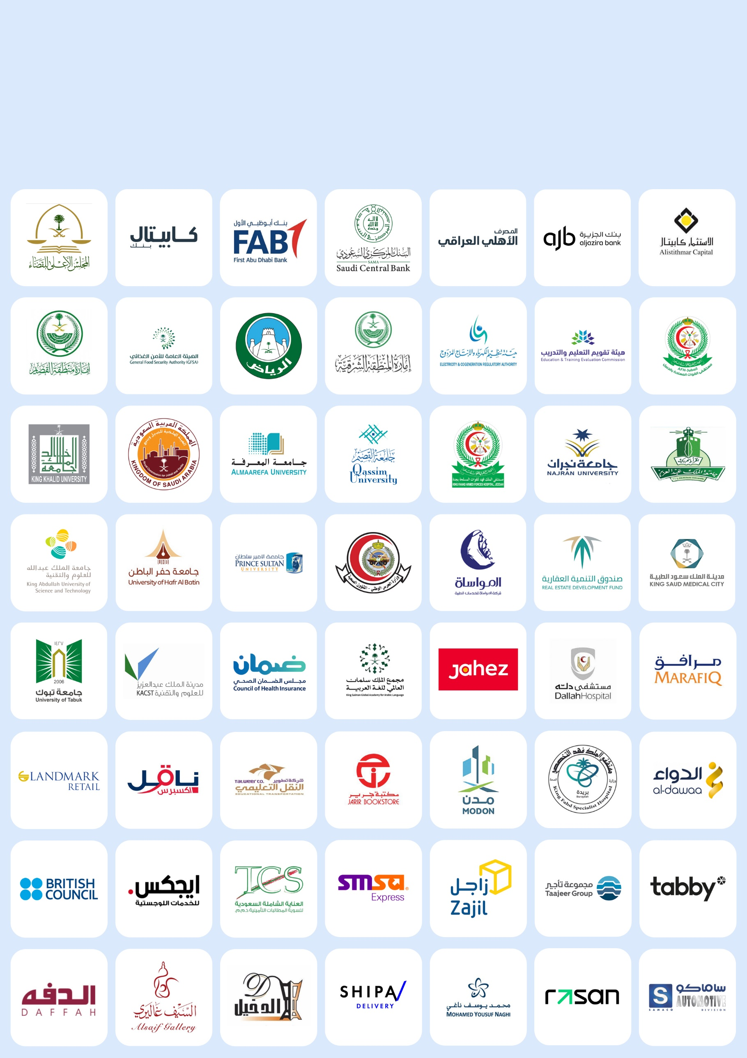
Choosing Successful People

TAQNYAT SMS platform connects you directly with the authorized service distributors from the official authorities in the Kingdom of Saudi Arabia and around the world and enables you to send messages to any number of recipients across the world through its online platform: www.taqnyat.sa

PRICES: PAYMENT METHOD
TAQNYAT is seeking to distribute high quality services to authorized providers at competitive prices. The individual and total cost are calculated in Saudi Riyals:

DESCRIPTION | QTY | PRICE | TOTAL | VAT 15% | TOTAL
Bulk SMS
Sender name fee
Tax Number | 300300775500003

NOTES
Terms & conditions applied
Offer validity: 10 Days.
Payment Terms: 100% advance payment.
The validity of the balance is only 1 year.

PAYMENTS
Bank Name: Ahli Bank.
Address: Jeddah.
Account Name : TAQNYAT ALJAWAL INFORMATION COMPANY
Account Number : 15500001405110
Account IBAN : SA5410000015500001405110
Account Currency : SAR

